I (patient name)______________________________________ (date of birth) _____________

Authorize:

Office Name: ________________________________

Office Phone number: ________________________

Office Email Address: _________________________

To transfer all copies of my dental records with respect to any dental care and treatment that I have received at your office to Plattsburgh Family Dentistry.
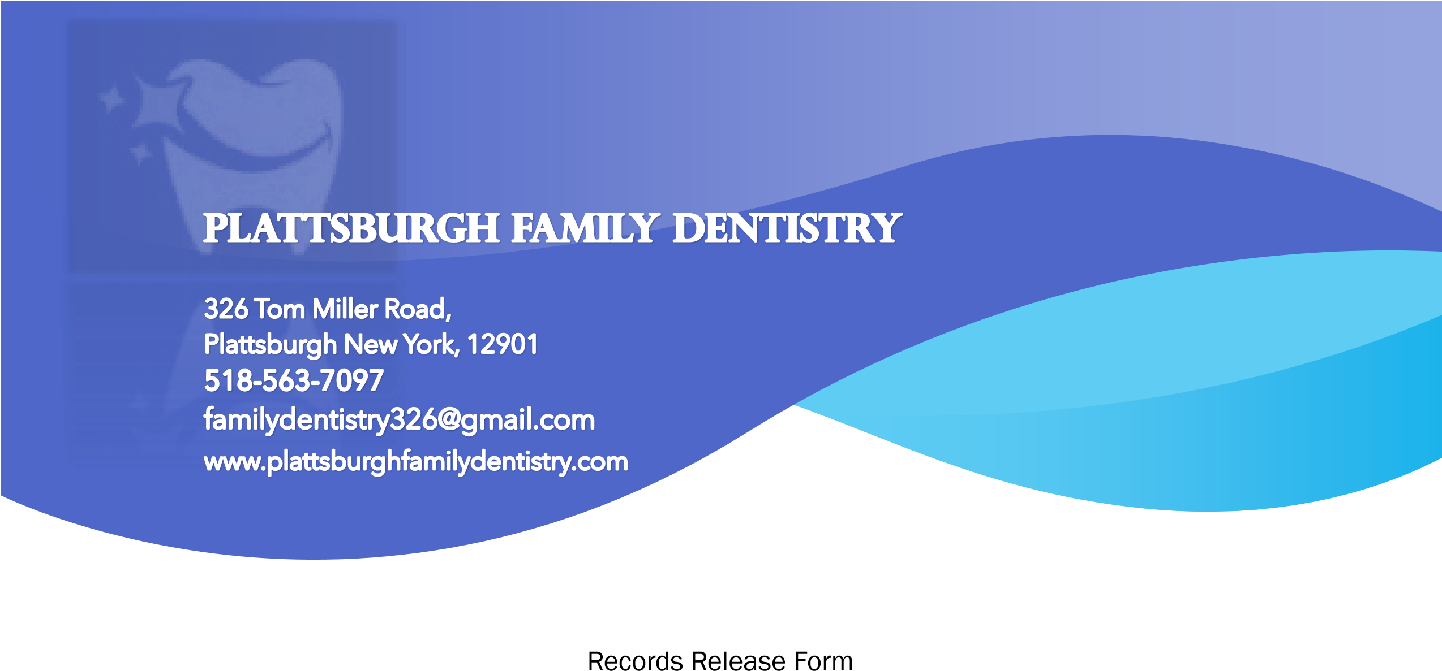

I understand that the specific type of information to be disclosed includes a detailed report of examinations, treatment provided, x-rays and all other records which pertain to me.

This consent is effective immediately upon signature.

Patient OR Guardian Signature: __________________________________ Date: ___________

Email all patient records to
Familydentistry326@gmail.com

